**Add Product Form**

* **Task Definition:**

Create one desktop application in WPF after the login page. (When login successfully handle). Then Main page should be open and hide the login form. Then click on add new Product menu item. Then add product form would be open

* **Tools and Technologies:**

Visual Studio

Entity Framework

* **Detailed Task Description**

I have divided this project into two modules

1. Main Form
2. New product Form

We can use Tab controls concept rather than menu. Means we don’t need to make menu we can make tab controls … I am referencing the tab control example.

<http://www.wpf-tutorial.com/tabcontrol/using-the-tabcontrol/>

<http://www.c-sharpcorner.com/uploadfile/prathore/tab-control-in-wpf/>

Using menu, I am giving you a link for example to create menu in WPF

<http://wpftutorial.net/Menus.html>

<http://www.codeproject.com/Articles/407547/Creation-of-Menu-and-submenu-in-WPF-desktop-applic>

So you need decide that we should create menu or tab on main form.

Currently I am giving you a main form using menu way.

**Main form**

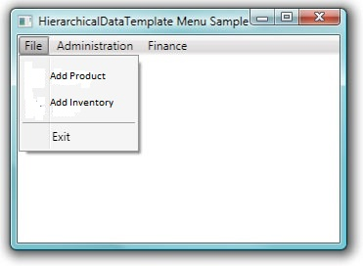

Table creation and all DB related activities should be done in entity framework.

In Main form, we will create a menu with name “Product Menu”. In this menu, we will create sub item menu with name “Add Product”. When we click on Add product Menu item, New form would be open for add product, which is mention below

**New Product Form**

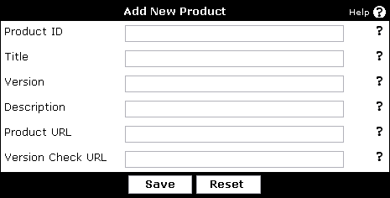

Main form always will be show behind the Product form. But login form would be hide when main form would be open

When we click on the Reset button, all textbox would be empty, When we click on save button, Data of text box would be save in data base in “Producttble” table

The column will be of “Producttble” table

|  |  |  |
| --- | --- | --- |
| Column Name | Datatype | Comments |
| Product_Id | int | Primary Key |
| ProductId | nvarchar |  |
| title | Nvarchar |  |
| Version | Nvarchar |  |
| Description | nvarchar |  |
| Product URl | nvarchar |  |
| Version check URl | nvarchar |  |
|  |  |  |